**STUDENT EXAMINATION PORTAL**

**Submitted by**

**Name of the Students: Aryan Shaw**

**Enrolment Number:** 12022002020058

**Section: C**

**Class Roll Number:** 23  
**Stream:** CSE AI

**Subject:** Programming for Problem Solving with Python

**Subject Code:** IVC101

**Department:** Basic Science and Humanities

Under the supervision of

Prof. Dr. Swarnendu Ghosh

**Academic Year: 2022-26**

PROJECT REPORT SUBMITTED IN PARTIAL FULFILLMENT OF THE REQUIREMENTS FOR THE FIRST SEMESTER



**DEPARTMENT OF BASIC SCIENCE AND HUMANITIES**

**INSTITUTE OF ENGINEERING AND MANAGEMENT, KOLKATA**



**CERTIFICATE OF RECOMMENDATION**

We hereby recommend that the project prepared under our supervision by Aryan Shaw**,** entitled STUDENT EXAMINATION PORTAL be accepted in partial fulfillment of the requirements for the degree of partial fulfillment of the first semester.

_____________________________ ______________________

Head of the Department Project Supervisor

Basic Sciences and Humanities

IEM, Kolkata

# Introduction

Nowadays, schools, colleges or any other educational organizations need a system to keep their students’ information, and the best way to maintain the record is by creating separate databases and storing the necessary data. There are so many ways to do the same. Using the “python” programming language we can quickly develop a code by running which we can take necessary data from the user and store it in the respective databases.

## Objective

The main objective of this project is to develop a python programme by which we can take data from user and store it in respective databases. This project makes us learn how to create a database, the relationships between several databases, and how we can easily create databases with simple python code.

## Organization of the Project

This project consists of three sections

**i) Taking data from the user:** When we run the programme a few terminal prompts instruct us to give the correct input.

**ii)Storing the data into different databases:** After taking the inputs from the user the code analyses data and store it in its respective databases.

# Database Descriptions

There are four databases:

1)STUDENT: Stores details of a student

2)COURSE: Stores details of all courses

3)BATCH: Stores details of all courses

4)DEPARTMENT: Stores details of all courses

# Data Flow and E-R Diagrams

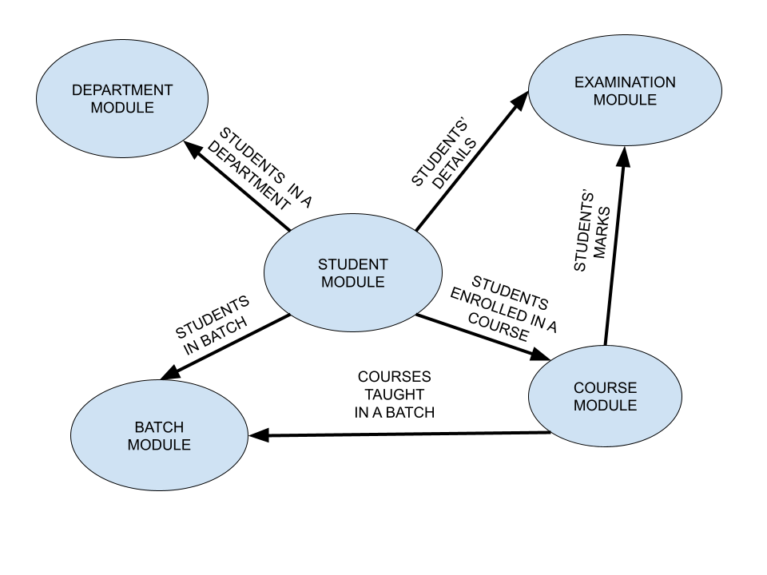

**MODULE STUDENT**

**Codes:-**

**import json**

**import csv**

**import pandas**

**from batch import createBatch**

**def createStudent(student_id, name):**

**class_roll_number = int(student_id[5:7])**

**batch_id = student_id[:5]**

**data = [student_id, name, class_roll_number, batch_id]**

**csv_reader = []**

**with open("student.csv", "r", newline = "\n") as f:**

**csv_reader = list(csv.reader(f, delimiter=","))**

**with open("student.csv", "a", newline = "\n") as f:**

**for i in range(0, len(csv_reader)):**

**if(csv_reader[i][0] == student_id):**

**print("Student ID already exists")**

**return**

**csv_writer = csv.writer(f)**

**csv_writer.writerow(data)**

**with open("batch.csv", "r", newline = "\n") as f:**

**csv_reader = list(csv.reader(f, delimiter=","))**

**check = 0**

**for i in range(0, len(csv_reader)):**

**if(csv_reader[i][0] == batch_id):**

**check = 1**

**if(csv_reader[i][4] == ""):**

**csv_reader[i][4] = csv_reader[i][4] + student_id**

**else:**

**csv_reader[i][4] = csv_reader[i][4] + ":" + student_id**

**df = pandas.read_csv("batch.csv")**

**df.loc[i-1, "list_of_students"] = csv_reader[i][4]**

**df.to_csv("batch.csv", index = False)**

**if(check == 0):**

**print("Batch does not exist.... Creating new batch")**

**batch_name = batch_id[:3] + " 20" + batch_id[3:] + "-" + str(int(batch_id[3:]) + 4)**

**createBatch(batch_name)**

**with open("batch.csv", "r", newline = "\n") as f:**

**csv_reader = list(csv.reader(f, delimiter=","))**

**courses = []**

**for i in range(0, len(csv_reader)):**

**if(csv_reader[i][0] == batch_id):**

**courses = list(csv_reader[i][3].split(":"))**

**with open("course.csv", "r", newline = "\n") as f:**

**csv_reader = list(csv.reader(f, delimiter=","))**

**for i in range(0, len(csv_reader)):**

**for j in range(0, len(courses)):**

**if(csv_reader[i][0] == courses[j]):**

**if(csv_reader[i][2] == ""):**

**temp = {}**

**temp[student_id] = 0**

**csv_reader[i][2] = json.dumps(temp)**

**else:**

**temp = json.loads(csv_reader[i][2])**

**temp[student_id] = 0**

**csv_reader[i][2] = json.dumps(temp)**

**df = pandas.read_csv("course.csv")**

**df.loc[i-1, "marks_obtained"] = csv_reader[i][2]**

**df.to_csv("course.csv", index = False)**

**def updateStudent(ostudent_id):**

**csv_reader = []**

**with open("student.csv", "r", newline = "\n") as f:**

**csv_reader = list(csv.reader(f, delimiter=","))**

**check = 0**

**for i in range(0, len(csv_reader)):**

**if(csv_reader[i][0] == ostudent_id):**

**check = 1**

**break**

**if(check == 0):**

**print("Student ID does not exist")**

**return**

**while(True):**

**print("Press 1 to update name")**

**print("Press 2 to update student ID")**

**print("Press 0 to exit")**

**x = int(input("Enter your choice: "))**

**if(x == 0):**

**break**

**elif(x == 1):**

**name = input("Enter updated name: ")**

**df = pandas.read_csv("student.csv")**

**df.loc[i-1, "Name"] = name**

**df.to_csv("student.csv", index = False)**

**elif(x == 2):**

**nstudent_id = input("Enter updated student ID: ")**

**df = pandas.read_csv("student.csv")**

**df.loc[i-1, "Student_ID"] = nstudent_id**

**df.to_csv("student.csv", index = False)**

**removeStudent(ostudent_id)**

**createStudent(nstudent_id, csv_reader[i][1])**

**ostudent_id = nstudent_id**

**with open("student.csv", "r", newline = "\n") as f:**

**csv_reader = list(csv.reader(f, delimiter=","))**

**else:**

**print("Invalid input. Try again.")**

**def removeStudent(student_id):**

**csv_reader = []**

**with open("student.csv", "r", newline = "\n") as f:**

**csv_reader = list(csv.reader(f, delimiter=","))**

**check = 0**

**for i in range(0, len(csv_reader)):**

**if(csv_reader[i][0] == student_id):**

**check = 1**

**break**

**if(check == 0):**

**print("Student ID does not exist")**

**return**

**df = pandas.read_csv("student.csv")**

**df.set_index("Student_ID")**

**df = df.drop(df.index[i-1])**

**df.to_csv("student.csv", index = False)**

**with open("course.csv", "r", newline = "\n") as f:**

**csv_reader = list(csv.reader(f, delimiter=","))**

**for i in range(0, len(csv_reader)):**

**if(i == 0):**

**continue**

**temp = csv_reader[i][2]**

**temp = json.loads(temp)**

**if student_id in temp:**

**del temp[student_id]**

**csv_reader[i][2] = json.dumps(temp)**

**df = pandas.read_csv("course.csv")**

**for i in range(1, len(csv_reader)):**

**df.loc[i-1, "marks_obtained"] = csv_reader[i][2]**

**df.to_csv("course.csv", index = False)**

**with open("batch.csv", "r", newline = "\n") as f:**

**csv_reader = list(csv.reader(f, delimiter=","))**

**for i in range(0, len(csv_reader)):**

**if(i == 0):**

**continue**

**temp = list(csv_reader[i][4].split(":"))**

**if student_id in temp:**

**temp.remove(student_id)**

**a = ":"**

**csv_reader[i][4] = a.join(temp)**

**df = pandas.read_csv("batch.csv")**

**for i in range(1, len(csv_reader)):**

**df.loc[i-1, "list_of_students"] = csv_reader[i][4]**

**df.to_csv("batch.csv", index = False)**

**def reportCard(student_id):**

**name = ""**

**csv_reader= []**

**with open("student.csv", "r", newline = "\n") as f:**

**csv_reader = list(csv.reader(f, delimiter=","))**

**check = 0**

**for i in range(0, len(csv_reader)):**

**if(csv_reader[i][0] == student_id):**

**check = 1**

**name = csv_reader[i][1]**

**break**

**if(check == 0):**

**print("Student ID does not exist")**

**return**

**f = open((student_id + ".txt"), "w")**

**a = "Student ID: " + student_id + "\n"**

**b = "Name: " + name + "\n"**

**f.writelines([a, b])**

**with open("course.csv", "r", newline = "\n") as fx:**

**csv_reader = list(csv.reader(fx, delimiter=","))**

**marks = []**

**subjects = []**

**for i in range(1, len(csv_reader)):**

**marks.append(json.loads(csv_reader[i][2]))**

**subjects.append(csv_reader[i][1])**

**total_marks = 0**

**divs = 0**

**for i in range(0, len(subjects)):**

**temp = marks[i]**

**if(isinstance(temp.get(student_id), int)):**

**subject_marks = "Marks in " + subjects[i] + ": " + str(temp.get(student_id)) + "% \n"**

**divs += 1**

**total_marks += temp.get(student_id)**

**f.write(subject_marks)**

**grade = "Grade obtained: " + gradeCheck(total_marks/divs) + " \n"**

**f.write(grade)**

**f.close()**

**def gradeCheck(a):**

**if(a >= 90):**

**return "A"**

**elif(a >= 80):**

**return "B"**

**elif(a >= 70):**

**return "C"**

**elif(a >= 60):**

**return "D"**

**elif(a >= 50):**

**return "E"**

**else:**

**return "F"**

output:

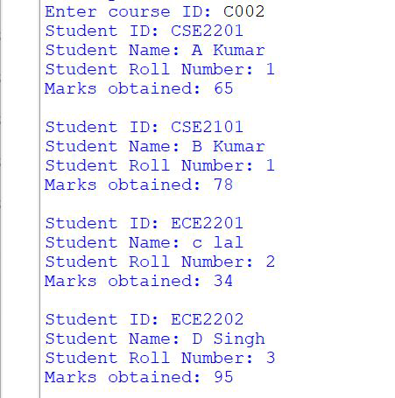

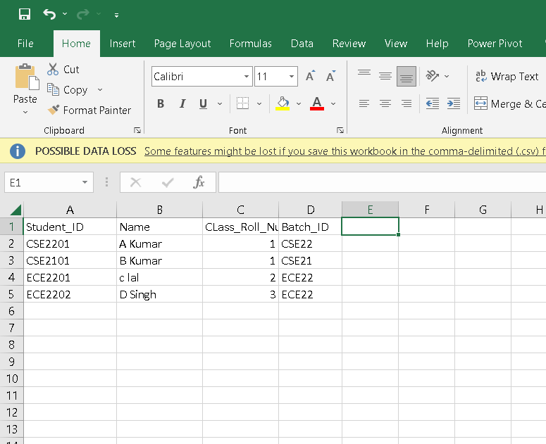

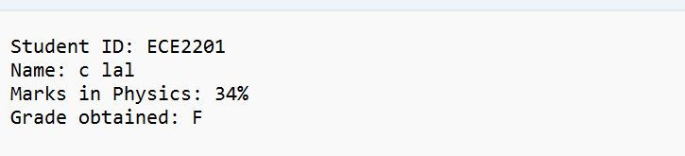

**MODULE COURSE**

**Codes:-**

**import json**

**import csv**

**import pandas**

**import matplotlib.pyplot**

**from collections import Counter**

**from student import gradeCheck**

**from batch import createBatch**

**def createCourse(course_id, course_name):**

**csv_reader = []**

**with open("course.csv", "r", newline = "\n") as f:**

**csv_reader = list(csv.reader(f, delimiter=","))**

**for i in range(0, len(csv_reader)):**

**if(csv_reader[i][0] == course_id):**

**print("Course ID already exists")**

**return**

**print("Enter batches in which course is included: ")**

**students = []**

**while(True):**

**batch_id = input("Enter batch ID (to stop enter STOP): ")**

**if(batch_id.upper() == "STOP"):**

**break**

**else:**

**check = 0**

**for i in range(0, len(csv_reader)):**

**with open("batch.csv", "r", newline = "\n") as f:**

**csv_reader = list(csv.reader(f, delimiter=","))**

**if(csv_reader[i][3] != ""):**

**temp = csv_reader[i][3].split(":")**

**for x in temp:**

**if(x == course_id):**

**print("Course already added")**

**continue**

**if(csv_reader[i][0] == batch_id):**

**check = 1**

**if(csv_reader[i][3] == ""):**

**csv_reader[i][3] = csv_reader[i][3] + course_id**

**else:**

**csv_reader[i][3] = csv_reader[i][3] + ":" + course_id**

**df = pandas.read_csv("batch.csv")**

**df.loc[i-1, "list_of_courses"] = csv_reader[i][3]**

**df.to_csv("batch.csv", index = False)**

**if(check == 0):**

**print("Batch does not exist.... Creating new batch")**

**batch_name = batch_id[:3] + " 20" + batch_id[3:] + "-" + str(int(batch_id[3:]) + 4)**

**createBatch(batch_name)**

**with open("batch.csv", "r", newline = "\n") as f:**

**csv_reader = list(csv.reader(f, delimiter=","))**

**csv_reader[len(csv_reader) - 1][3] = csv_reader[len(csv_reader) - 1][3] + course_id**

**df = pandas.read_csv("batch.csv")**

**df.loc[len(csv_reader) - 2, "list_of_courses"] = csv_reader[len(csv_reader) - 1][3]**

**df.to_csv("batch.csv", index = False)**

**with open("batch.csv", "r", newline = "\n") as f:**

**csv_reader = list(csv.reader(f, delimiter=","))**

**for i in range(0, len(csv_reader)):**

**if(csv_reader[i][0] == batch_id):**

**students += csv_reader[i][4].split(":")**

**temp = {}**

**for a in students:**

**temp[a] = 0**

**data = [course_id, course_name, json.dumps(temp)]**

**with open("course.csv", "a", newline = "\n") as f:**

**csv_writer = csv.writer(f)**

**csv_writer.writerow(data)**

**def checkPerformance(course_id):**

**csv_reader = []**

**data = []**

**with open("course.csv", "r", newline = "\n") as f:**

**csv_reader = list(csv.reader(f, delimiter=","))**

**check = 0**

**student_marks = {}**

**for i in range(1, len(csv_reader)):**

**if(csv_reader[i][0] == course_id):**

**check = 1**

**student_marks = json.loads(csv_reader[i][2])**

**break**

**if(check == 0):**

**print("Course ID does not exist")**

**return data**

**student_ids = list(student_marks.keys())**

**with open("student.csv", "r", newline = "\n") as f:**

**csv_reader = list(csv.reader(f, delimiter=","))**

**for i in range(0, len(student_ids)):**

**for j in range(0, len(csv_reader)):**

**if(student_ids[i] == csv_reader[j][0]):**

**print("Student ID: " + student_ids[i])**

**print("Student Name: " + csv_reader[j][1])**

**print("Student Roll Number: " + csv_reader[j][2])**

**print("Marks obtained: " + str(student_marks.get(student_ids[i])))**

**print()**

**data.append([student_ids[i], csv_reader[j][1], csv_reader[j][2], student_marks.get(student_ids[i])])**

**return data**

**def courseStatistics(course_id):**

**csv_reader = []**

**with open("course.csv", "r", newline = "\n") as f:**

**csv_reader = list(csv.reader(f, delimiter=","))**

**check = 0**

**for i in range(0, len(csv_reader)):**

**if(csv_reader[i][0] == course_id):**

**check = 1**

**break**

**if(check == 0):**

**print("Course ID does not exist")**

**return**

**x = checkPerformance(course_id)**

**grades = []**

**for a in x:**

**grades.append(gradeCheck(a[3]))**

**grades.sort()**

**letter_counts = Counter(grades)**

**df = pandas.DataFrame.from_dict(letter_counts, orient='index')**

**df.plot(kind='bar')**

**matplotlib.pyplot.show()**

output:

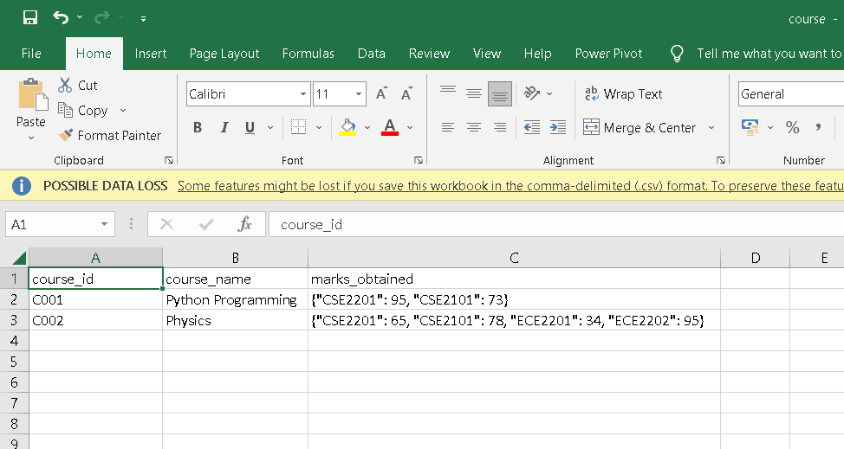

Histogram:

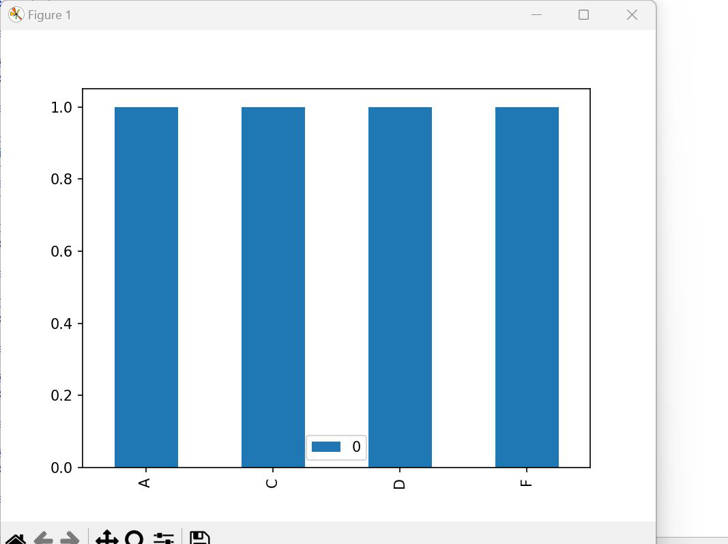

MODULE BATCH

Codes:-

**import csv**

**import pandas**

**import json**

**from matplotlib import pyplot**

**from department import createDepartment**

**def createBatch(batch_name):**

**batch_id = batch_name[:3] + batch_name[6:8]**

**department_id = batch_id[:3]**

**csv_reader = []**

**with open("batch.csv", "r", newline = "\n") as f:**

**csv_reader = list(csv.reader(f, delimiter=","))**

**for i in range(0, len(csv_reader)):**

**if(csv_reader[i][0] == batch_id):**

**print("Batch ID already exists")**

**return**

**data = [batch_id, batch_name, department_id, "", ""]**

**with open("batch.csv", "a", newline = "\n") as f:**

**csv_writer = csv.writer(f)**

**csv_writer.writerow(data)**

**print("Enter courses in batch: ")**

**while(True):**

**course_id = input("Enter course ID (to stop enter STOP): ")**

**with open("batch.csv", "r", newline = "\n") as f:**

**csv_reader = list(csv.reader(f, delimiter=","))**

**if(csv_reader[len(csv_reader) - 1][3] != ""):**

**check = 0**

**temp = csv_reader[len(csv_reader) - 1][3].split(":")**

**for x in temp:**

**if(x == course_id):**

**print("Course already added")**

**check = 1**

**if(check == 1):**

**continue**

**if(course_id.upper() == "STOP"):**

**break**

**else:**

**with open("course.csv", "r", newline = "\n") as f:**

**csv_reader = list(csv.reader(f, delimiter=","))**

**check = 0**

**for i in range(0, len(csv_reader)):**

**if(csv_reader[i][0] == course_id):**

**with open("batch.csv", "r", newline = "\n") as f:**

**csv_reader = list(csv.reader(f, delimiter=","))**

**check = 1**

**if(csv_reader[len(csv_reader) - 1][3] == ""):**

**csv_reader[len(csv_reader) - 1][3] = csv_reader[len(csv_reader) - 1][3] + course_id**

**else:**

**csv_reader[len(csv_reader) - 1][3] = csv_reader[len(csv_reader) - 1][3] + ":" + course_id**

**df = pandas.read_csv("batch.csv")**

**df.loc[len(csv_reader) - 2, "list_of_courses"] = csv_reader[len(csv_reader) - 1][3]**

**df.to_csv("batch.csv", index = False)**

**if(check == 0):**

**print("Course does not exist. Please create course first.")**

**with open("department.csv", "r", newline = "\n") as f:**

**csv_reader = list(csv.reader(f, delimiter=","))**

**check = 0**

**for i in range(0, len(csv_reader)):**

**if(csv_reader[i][0] == department_id):**

**check = 1**

**if(csv_reader[i][2] == ""):**

**csv_reader[i][2] = csv_reader[i][2] + batch_id**

**else:**

**csv_reader[i][2] = csv_reader[i][2] + ":" + batch_id**

**df = pandas.read_csv("department.csv")**

**df.loc[i-1, "list_of_batches"] = csv_reader[i][2]**

**df.to_csv("department.csv", index = False)**

**if(check == 0):**

**print("Department does not exist.... Creating new department")**

**department_name = input("Enter department name: ")**

**createDepartment(department_id, department_name)**

**with open("department.csv", "r", newline = "\n") as f:**

**csv_reader = list(csv.reader(f, delimiter=","))**

**csv_reader[len(csv_reader) - 1][2] = csv_reader[len(csv_reader) - 1][2] + batch_id**

**df = pandas.read_csv("department.csv")**

**df.loc[len(csv_reader) - 2, "list_of_batches"] = csv_reader[len(csv_reader) - 1][2]**

**df.to_csv("department.csv", index = False)**

**def viewStudents(batch_id):**

**with open("batch.csv", "r", newline = "\n") as f:**

**csv_reader = list(csv.reader(f, delimiter=","))**

**check = 0**

**students = []**

**for i in range(0, len(csv_reader)):**

**if(csv_reader[i][0] == batch_id):**

**check = 1**

**students = csv_reader[i][4].split(":")**

**break**

**if(check == 0):**

**print("Batch ID does not exist")**

**return**

**print("Students in " + batch_id + ":")**

**for student in students:**

**print(student)**

**def viewCourses(batch_id):**

**with open("batch.csv", "r", newline = "\n") as f:**

**csv_reader = list(csv.reader(f, delimiter=","))**

**check = 0**

**courses = []**

**for i in range(0, len(csv_reader)):**

**if(csv_reader[i][0] == batch_id):**

**check = 1**

**courses = csv_reader[i][3].split(":")**

**break**

**if(check == 0):**

**print("Batch ID does not exist")**

**return**

**print("Courses in " + batch_id + ":")**

**for course in courses:**

**print(course)**

**def viewPerformance(batch_id):**

**with open("batch.csv", "r", newline = "\n") as f:**

**csv_reader = list(csv.reader(f, delimiter=","))**

**check = 0**

**students = []**

**for i in range(0, len(csv_reader)):**

**if(csv_reader[i][0] == batch_id):**

**check = 1**

**students = csv_reader[i][4].split(":")**

**break**

**if(check == 0):**

**print("Batch ID does not exist")**

**return**

**for student in students:**

**with open("student.csv", "r", newline = "\n") as f:**

**csv_reader = list(csv.reader(f, delimiter=","))**

**for i in range(0, len(csv_reader)):**

**if(student == csv_reader[i][0]):**

**print("Student ID: " + student)**

**print("Student Name: " + csv_reader[i][1])**

**print("Student Roll Number: " + csv_reader[i][2])**

**with open("course.csv", "r", newline = "\n") as f:**

**csv_reader = list(csv.reader(f, delimiter=","))**

**all_marks = []**

**for i in range(1, len(csv_reader)):**

**all_marks.append(json.loads(csv_reader[i][2]))**

**total_marks = 0**

**divs = 0**

**for subjects in all_marks:**

**if(isinstance(subjects.get(student), int)):**

**total_marks += subjects.get(student)**

**divs += 1**

**print("Percentage obtained: " + str(total_marks/divs))**

**print()**

**def pieChart(batch_id):**

**with open("batch.csv", "r", newline = "\n") as f:**

**csv_reader = list(csv.reader(f, delimiter=","))**

**check = 0**

**students = []**

**for i in range(0, len(csv_reader)):**

**if(csv_reader[i][0] == batch_id):**

**check = 1**

**students = csv_reader[i][4].split(":")**

**break**

**if(check == 0):**

**print("Batch ID does not exist")**

**return**

**percentages = [">=90", ">=80", ">=70", ">=60", ">=50", "Failed"]**

**numbers = [0, 0, 0, 0, 0, 0]**

**for student in students:**

**with open("course.csv", "r", newline = "\n") as f:**

**csv_reader = list(csv.reader(f, delimiter=","))**

**all_marks = []**

**for i in range(1, len(csv_reader)):**

**all_marks.append(json.loads(csv_reader[i][2]))**

**total_marks = 0**

**divs = 0**

**for subjects in all_marks:**

**if(isinstance(subjects.get(student), int)):**

**total_marks += subjects.get(student)**

**divs += 1**

**percentage = total_marks/divs**

**if(percentage >= 90):**

**numbers[0] += 1**

**elif(percentage >= 80):**

**numbers[1] += 1**

**elif(percentage >= 70):**

**numbers[2] += 1**

**elif(percentage >= 60):**

**numbers[3] += 1**

**elif(percentage >= 50):**

**numbers[4] += 1**

**else:**

**numbers[5] += 1**

**for i in range(len(numbers) - 1, -1, -1):**

**if(numbers[i] == 0):**

**del numbers[i]**

**del percentages[i]**

**pyplot.pie(numbers, labels = percentages)**

**pyplot.show()**

output:

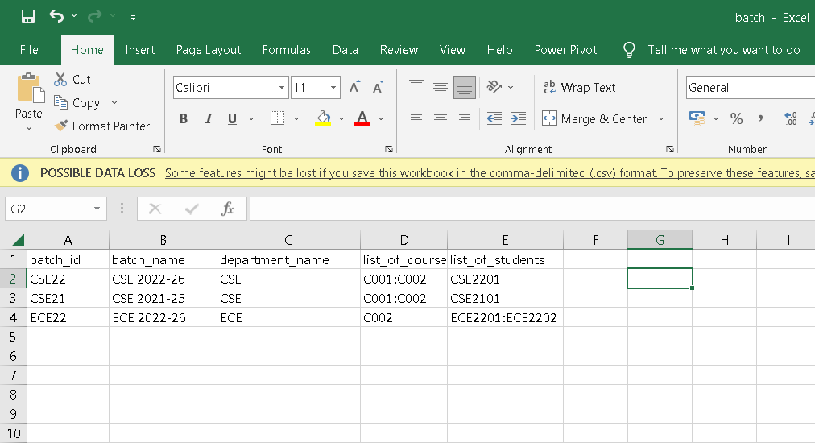

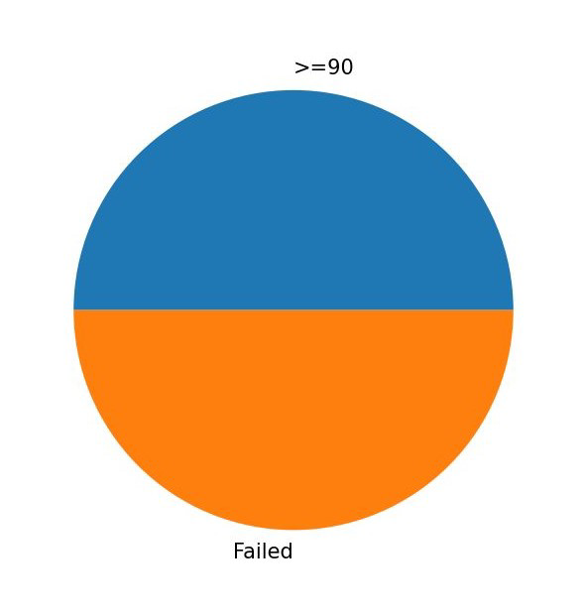

MODULE DEPARTMENT:

Codes:-

**import json**

**import csv**

**from matplotlib import pyplot**

**def createDepartment(department_id, department_name):**

**csv_reader = []**

**with open("department.csv", "r", newline = "\n") as f:**

**csv_reader = list(csv.reader(f, delimiter=","))**

**for i in range(0, len(csv_reader)):**

**if(csv_reader[i][0] == department_id):**

**print("Department ID already exists")**

**return**

**data = [department_id, department_name, ""]**

**with open("department.csv", "a", newline = "\n") as f:**

**csv_writer = csv.writer(f)**

**csv_writer.writerow(data)**

**def viewBatches(department_id):**

**with open("department.csv", "r", newline = "\n") as f:**

**csv_reader = list(csv.reader(f, delimiter=","))**

**check = 0**

**batches = []**

**for i in range(0, len(csv_reader)):**

**if(csv_reader[i][0] == department_id):**

**check = 1**

**batches = csv_reader[i][2].split(":")**

**break**

**if(check == 0):**

**print("Department ID does not exist")**

**return**

**print("Batches in " + department_id + ":")**

**for batch in batches:**

**print(batch)**

**def viewPerformanceD(department_id):**

**with open("department.csv", "r", newline = "\n") as f:**

**csv_reader = list(csv.reader(f, delimiter=","))**

**check = 0**

**batches = []**

**for i in range(1, len(csv_reader)):**

**if(csv_reader[i][0] == department_id):**

**check = 1**

**batches = csv_reader[i][2].split(":")**

**break**

**if(check == 0):**

**print("Department ID does not exist")**

**return**

**if(len(batches) == 0):**

**print("No batches in department")**

**return**

**performances = []**

**for batch in batches:**

**students = []**

**student_performances = []**

**with open("batch.csv", "r", newline = "\n") as f:**

**csv_reader = list(csv.reader(f, delimiter=","))**

**for i in range(0, len(csv_reader)):**

**if(csv_reader[i][0] == batch):**

**students = csv_reader[i][4].split(":")**

**break**

**for student in students:**

**with open("course.csv", "r", newline = "\n") as f:**

**csv_reader = list(csv.reader(f, delimiter=","))**

**all_marks = []**

**for i in range(1, len(csv_reader)):**

**all_marks.append(json.loads(csv_reader[i][2]))**

**total_marks = 0**

**divs = 0**

**for subjects in all_marks:**

**if(isinstance(subjects.get(student), int)):**

**total_marks += subjects.get(student)**

**divs += 1**

**if(divs != 0):**

**student_performances.append(total_marks/divs)**

**else:**

**student_performances.append(0)**

**total_marks = 0**

**divs = 0**

**for x in student_performances:**

**total_marks += x**

**divs += 1**

**if(divs != 0):**

**performances.append(total_marks/divs)**

**else:**

**performances.append(0)**

**total_marks = 0**

**divs = 0**

**for i in range(0, len(batches)):**

**total_marks += performances[i]**

**divs += 1**

**avg_percentage = 0**

**if(divs != 0):**

**avg_percentage = total_marks/divs**

**print("Average percantage obtained by all batches in " + department_id + ": " + str(avg_percentage))**

**def linePlot(department_id):**

**with open("department.csv", "r", newline = "\n") as f:**

**csv_reader = list(csv.reader(f, delimiter=","))**

**check = 0**

**batches = []**

**for i in range(1, len(csv_reader)):**

**if(csv_reader[i][0] == department_id):**

**check = 1**

**batches = csv_reader[i][2].split(":")**

**break**

**if(check == 0):**

**print("Department ID does not exist")**

**return**

**if(len(batches) == 0):**

**print("No batches in department")**

**return**

**performances = []**

**for batch in batches:**

**students = []**

**student_performances = []**

**with open("batch.csv", "r", newline = "\n") as f:**

**csv_reader = list(csv.reader(f, delimiter=","))**

**for i in range(0, len(csv_reader)):**

**if(csv_reader[i][0] == batch):**

**students = csv_reader[i][4].split(":")**

**break**

**for student in students:**

**with open("course.csv", "r", newline = "\n") as f:**

**csv_reader = list(csv.reader(f, delimiter=","))**

**all_marks = []**

**for i in range(1, len(csv_reader)):**

**all_marks.append(json.loads(csv_reader[i][2]))**

**total_marks = 0**

**divs = 0**

**for subjects in all_marks:**

**if(isinstance(subjects.get(student), int)):**

**total_marks += subjects.get(student)**

**divs += 1**

**if(divs != 0):**

**student_performances.append(total_marks/divs)**

**else:**

**student_performances.append(0)**

**total_marks = 0**

**divs = 0**

**for x in student_performances:**

**total_marks += x**

**divs += 1**

**if(divs != 0):**

**performances.append(total_marks/divs)**

**else:**

**performances.append(0)**

**pyplot.plot(batches, performances)**

**pyplot.show()**

ouput:

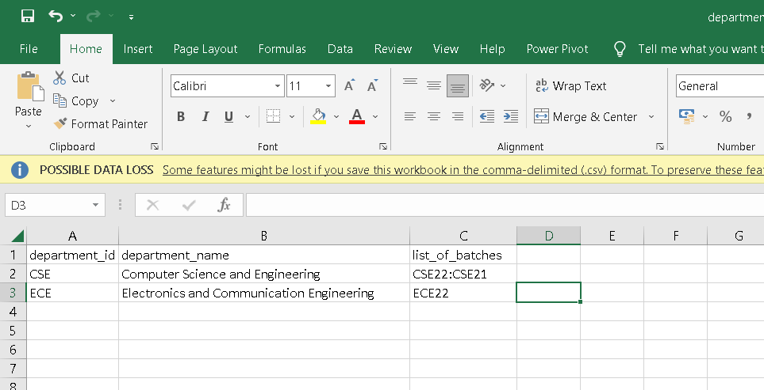

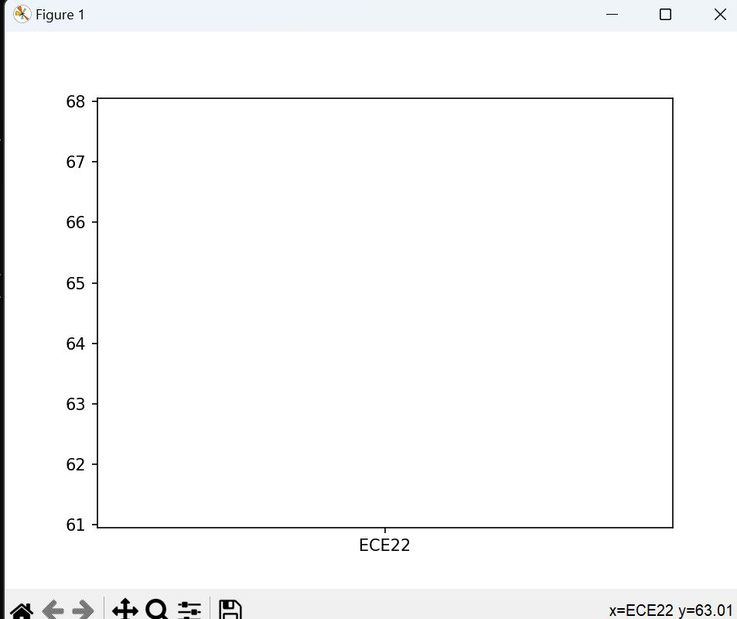

**MODULE EXAMINATION:**

**Codes:-**

**import csv**

**import json**

**import pandas**

**from matplotlib import pyplot**

**def enterMarks(course_id):**

**csv_reader = []**

**with open("course.csv", "r", newline = "\n") as f:**

**csv_reader = list(csv.reader(f, delimiter=","))**

**check = 0**

**course_name = ""**

**student_marks = {}**

**for i in range(1, len(csv_reader)):**

**if(csv_reader[i][0] == course_id):**

**check = 1**

**course_name = csv_reader[i][1]**

**student_marks = json.loads(csv_reader[i][2])**

**break**

**if(check == 0):**

**print("Course ID does not exist")**

**return**

**student_ids = list(student_marks.keys())**

**print("Course name: " + course_name)**

**for student in student_ids:**

**marks = int(input("Enter marks obtained by " + student + ": "))**

**student_marks[student] = marks**

**df = pandas.read_csv("course.csv")**

**df.loc[i - 1, "marks_obtained"] = json.dumps(student_marks)**

**df.to_csv("course.csv", index = False)**

**def viewPerformanceE(course_id):**

**csv_reader = []**

**with open("course.csv", "r", newline = "\n") as f:**

**csv_reader = list(csv.reader(f, delimiter=","))**

**check = 0**

**student_marks = {}**

**for i in range(0, len(csv_reader)):**

**if(csv_reader[i][1] == course_id):**

**check = 1**

**student_marks = json.loads(csv_reader[i][2])**

**break**

**if(check == 0):**

**print("Course ID does not exist")**

**return**

**student_ids = list(student_marks.keys())**

**for student in student_ids:**

**marks = student_marks[student]**

**print("Marks obtained by " + str(marks))**

**def scatterPlot():**

**csv_reader = []**

**with open("course.csv", "r", newline = "\n") as f:**

**csv_reader = list(csv.reader(f, delimiter=","))**

**all_marks = []**

**for i in range(1, len(csv_reader)):**

**all_marks.append(json.loads(csv_reader[i][2]))**

**batches = []**

**students = []**

**with open("batch.csv", "r", newline = "\n") as f:**

**csv_reader = list(csv.reader(f, delimiter=","))**

**for i in range(0, len(csv_reader)):**

**batches.append(csv_reader[i][0])**

**students.append(csv_reader[i][4].split(":"))**

**for course in all_marks:**

**batch_performances = []**

**batchesX = []**

**for i in range(0, len(batches)):**

**total_marks = 0**

**divs = 0**

**check = 0**

**for student in students[i]:**

**if(student == students[i][0]):**

**if(not isinstance(course.get(student), int)):**

**check = 1**

**break**

**total_marks += course.get(student)**

**divs += 1**

**if(check == 1):**

**continue**

**else:**

**batchesX.append(batches[i])**

**batch_performances.append(total_marks/divs)**

**pyplot.scatter(batchesX, batch_performances)**

**pyplot.show()**

output:

